Discussing the most common mistakes found (HW3)

When using growth functions formulated as difference equations the data sets require some restructuring in order to pair subsequent measurements of the same plot. The modeler has to guarantee that only pairs of data of the same plot (and same rotation) are included in the final data set.
Integral form  Lundqvist-korf | Difference equation formulation  Lundqvist-korf (K-free parameter)
$$G=A e^{-k\left(\frac{1}{t^{m}}\right)}$$ | $$G_{2}=A{\left(\frac{G_{1}}{A}\right)}^{{\left(\frac{t_{1}}{t_{2}}\right)}^{m}}$$
Data structure:
Because there is no BEST METHOD to develop a growth model, it is common that different methods are combined. For example, formulating growth functions as difference equations (ADA) while expressing one or more parameters as a function of site and/or stand variables (e.g. S and N1, N2, respectively). When combining these 2 methods, many models can derive depending on the set of variables the modeler choses to include in each of the parameters and the relationship considered to exist between the parameter and the variables (e.g. linear, exponential, etc).
As a function of site variables:  $$G_{2}=\left(a_{0}+a_{1}S\right){\left(\frac{G_{1}}{\left(a_{0}+a_{1}S\right)}\right)}^{{\left(\frac{t_{1}}{t_{2}}\right)}^{m}}$$ | As a function of both site and stand variables:  $$G_{2}=\left(a_{0}+a_{1}S\right){\left(\frac{G_{1}}{\left(a_{0}+a_{1}S\right)}\right)}^{\left(\frac{{t_{1}}^{\left(m_{0}+m_{1} N_{1}\right)}}{{t_{2}}^{\left(m_{0}+m_{1} N_{2}\right)}}\right)}$$
In both examples above it has been assumed a linear relationship exists between the parameters and the site and stand variables: A = a0 + a1 S and mi = m0 + m1 N_{i} with i = 1,2, but is might not be so. There are situation where the relationship might not be linear e.g. ( A = a1 S²; mi = m0 + m1 ln(S) + m2 Ni/1000). As you may have noticed from these examples, stand and site variables can be used plain, but also their square, logarithm, root, products of different variables, divided by 1000, 100 or 10 (to avoid parameter values with a lot of zeros, e.g. 0.00003154 and this way guaranteeing the same dimension for all parameters) etc.

Out of all of the resulting models, the modeler usually chooses what seems to be the best model based on the purpose of use, the statistical characteristics and the biologic meaning of the models. Sometimes, simplicity is also taken into account. When applying solver, you only had access to the sum of squares as an indicator of model quality. You could have also performed a graphical analysis to assess the performance of the model. However, statistical software’s will allow testing several combinations of variables and variable variants for expressing parameter values. Adding to this, software’s are able to produce a wider range of statistical indicators of model performance that can help you select the best model. A flexibility that Excel does not have.
When selecting the variables to include in the model, make sure you choose the right ones and before minimizing the sum of squares guarantee that you’re selecting not only the right variable but the correct instant in time.
If after fitting the model, a parameter that multiplies a site or stand variable is null, this might indicate your dataset does not show a substantial variation for that particular variable capable of affecting the variable you want to model.
Take the following model as an example:
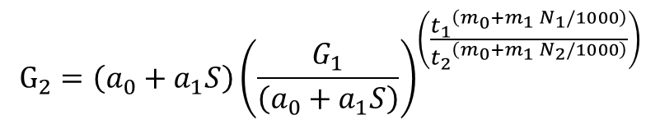

If after you fit the model above you get : a0=0 and m1=0, your final model is:

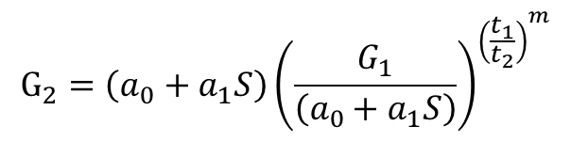
If after you fit the model above and you get : a1=0, your final model is:

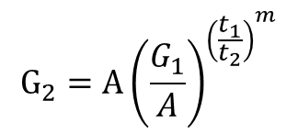

On the other hand, it might mean that you have formatted your value to a number of decimal places that only shows zeros (e.g. when you should have divided the variable by 1000, as commonly happens for Stand Density, to guarantee that all your parameters have the same decimal places/scale).
When using Excel or any other software please make sure you write your equations correctly avoiding the excessive use of parenthesis that often leads to making mistakes. Take the following examples of the different ways you’ve used to write the equation bellow:
(a0+(a1*S))*(G1/(a0+(a1*S)))^(t1/t2)^(m0+(m1*N1))
(a0+a1*S)*((G1/(a0+a1*S))^(((t1^(m0+m1*N1))/(t2^(m0+m1*N1)))))
(a0+(a1*S) )*(((G1/(a0+(a1*S))^((t1^(m0+m1*N1)/(t2^(m0+m1*N2)))))))
((a0+a1*S)*(G1/(a0+a1*S)))^(((B4^( m0+m1*N1)/(C4^( m0+m1*N2)))))
When trying to write a function in Excel the cell returns “#Num!” this might mean you’re using a set of initial values for your parameters that makes no sense. Try to start from the set of parameters obtained when fitting the previous/simplest model version INSTEAD of changing the equation (see the example below).

(a0+a1*S)*(G1/( a0+a1*S))^(((B7*( m0+m1*N1))/(C7*( m0+m1*N2))))
Finally, when implementing the equations always keep in mind the rules for mathematical calculations:
"Operations" mean things like add, subtract, multiply, divide, squaring, etc. Long ago mathematicians agreed to follow rules when doing calculations and this implies following an order. Calculate them in the wrong order, and you can get a wrong answer! So in this example what should you do first?
7 + (6 × 5² + 3)
P | Parentheses first
E | Exponents (ie Powers and Square Roots, etc.)
MD | Multiplication and Division (left-to-right)
AS | Addition and Subtraction (left-to-right)
Do things in Parentheses First
 |  | 4 × (5 + 3) | = | 4 × 8 | = | 32 | (right)
 |  | 4 × (5 + 3) | = | 20 + 3 | = | 23 | (wrong)
Exponents (Powers, Roots) before Multiply, Divide, Add or Subtract
 |  | 5 × 2² | = | 5 × 4 | = | 20 | (right)
 |  | 5 × 2² | = | 10² | = | 100 | (wrong)
Multiply or Divide before you Add or Subtract
 |  | 2 + 5 × 3 | = | 2 + 15 | = | 17 | (right)
 |  | 2 + 5 × 3 | = | 7 × 3 | = | 21 | (wrong)
Otherwise just go left to right
 | 30 ÷ 5 × 3 | = | 6 × 3 | = | 18 | (right)
 | 30 ÷ 5 × 3 | = | 30 ÷ 15 | = | 2 | (wrong)
Divide and Multiply rank equally (and go left to right).
Add and Subtract rank equally (and go left to right)

