FOREST MODELS COURSE
EXERCICES TO SUPPORT THE STUDY OF THE 3PG MODEL

Use the 3PG model to analyze the impact of climate change in the productivity of eucalyptus stands located in the Chamusca county. For that you should:

Obtain two scenarios of climate data for the Chamusca county: i) average climate of the last 30 years; ii) two climate change scenarios. Suggestion: use the climate picker tool from sIMfLOR (or directly from the site http://home.isa.utl.pt/~joaopalma/modelos/simflor/utils/map/map.html) that includes the HadRM3Q0 A1B2 climate scenarios for the period 1951 to 2099, using climate from different periods to simulate the different climate scenarios.
HELP:
Find Chamusca in the map (suggestion: Google maps and search for Chamusca to copy/paste coordinates in this page) and download the climatic files:
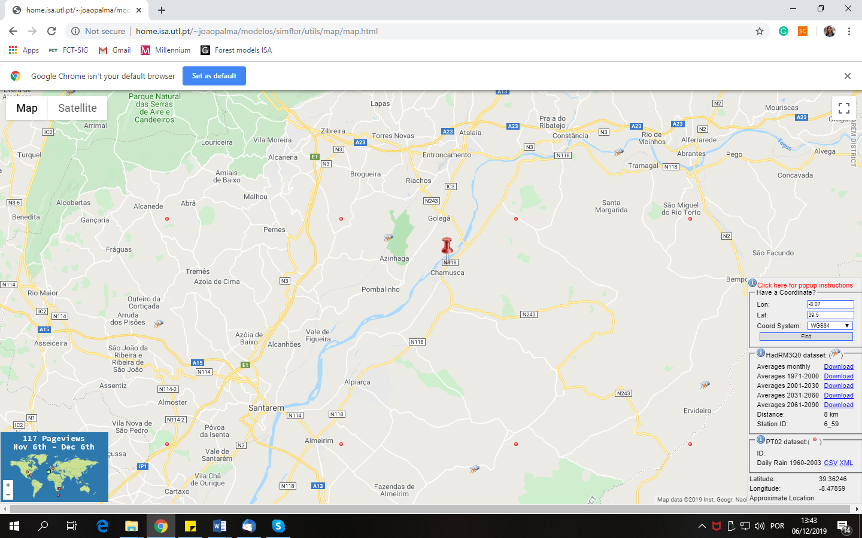

MetStationX – Meteorological station relative coordinate x  MetStationY - Meteorological station relative coordinate x  Year - Year  Month - Month  Tmean - Mean temperature (ºC)  Tmax - Maximum temperature (ºC)  Tmin – Minimum temperature (ºC) | Rain – Precipitation (mm)  SolarRad – Solar radiation  RainDays_gt1 - Number of days with rain above 1 mm  FrostDays - Number of days with frost  VPD – Vapor Pressure Deficit  RainDays_gt01 – Number of days with rain above 0.1 mm  Evap - Evapotranspiration  RelHum – Relative humidity

Characterize the environment in Chamusca. Some information: i) the range of site indices in the county is the one obtained in the forest inventory data represented in figure 1; ii) the more frequent texture of the soils in Chamusca is sandy (in 3PG s or 1); ii) assuming an average fertility you may start by using FR=0.5

Figure 1. Distribution of site indices values in the Chamusca county.

You must make simulations from the seedling status using a common number of trees at planting, e.g. 1250 (spacing 4x2). Use the 3PG-out+ equation to estimate dominant height (table 1).

Use the 3PG model and the climate equal to the average of the last 30 years to find ASW values appropriate to simulate stands with productivities equivalent to the different site indices present in the county

Predict the productivity under two alternative climate scenarios
- Repeat the exercise but using different FR values

Discuss the results

File “PermanentPlots-Ec-S-data.xls” contains data from some permanent plots established in eucalyptus plantations in Portugal, close to Óbidos (Furadouro farm). All the stands were established at a 3x3 spacing.
The file contains stand data obtained from the measurement of the plots, as well as data for the initialization of 3PG and climatic data from a nearby station (note that the climate data are equal for the 4 plots).

Simulate the growth of each plot with the 3PG-out⁺ model and compare the estimated with the observed values (see table 1 for the 3PG out+ equations)

Illustrate, for each plot, the evolution of dominant height, basal area and volume as well as the mean and current annual increments in volume (plot the two increments in the same graphic)

Find the observed and estimated site index (base age 10) for each one of the plots

Analyze the location of the maximum of the mean annual increment in volume and relate it with the site index

Repeat questions a) to d) but initializing the 3PG with seedlings

Discuss the results

Repeat questions a) to f) with the GLOBULUS model (with standsSIM)

File “PermanentPlots-Ec-Npl-data.xls” contains data from the plots of one block of a spacing trial established in eucalyptus plantations in Portugal. Being a block, all the plots have a similar site index.
The file contains stand data obtained from the measurement of the plots, as well as data for the initialization of 3PG and climatic data from a nearby station (note that the climate data are equal for the 5 plots).

Simulate the growth of each plot with the 3PG-out+ model and compare the estimated with the observed values (see table 1 for the 3PG out+ equations):

Illustrate, for each plot, the evolution of dominant height, basal area and volume as well as the mean and current annual increments in volume (plot the two increments in the same graphic)

Find the observed and estimated site index (base age 10) for each one of the plots

Analyze the location of the maximum of the mean annual increment in volume and relate it with the initial stand density (spacing)

Illustrate, for each plot, the evolution of the biomass per tree component as well as the total biomass

Repeat questions a) to d) but initializing the 3PG with seedlings

Discuss the results

Repeat questions a) to f) with the GLOBULUS model (with standsSIM)

Table 1 – 3PG out+ equations for variables used by forest managers (Oliveira 2014)
Model | Analytical expression
 | Initialization | Projection
Basal area  (G, m² ha⁻¹) | [8] $G_{ }=k {W_{a }}^{a1 + a2 \frac{N}{10000}}$ | [9] $G_{t2}= G_{t1} {\left(\frac{{W_{a 2 }}^{a1+a2 \frac{N_{2}}{10000}}}{{W_{a 1}}^{a1+a2 \frac{N_{1}}{10000}}} \right)}^{ }$
 | k=0. 87731; a1=0. 63575; a2=0. 225229
Dominant height  (hdom, m) | [10] ${hdom}_{ }=k {W_{wy}}^{a1+a2 {\frac{N}{10000}}_{ }}$ | [11] ${hdom}_{t2}= {hdom}_{t1} {\left(\frac{{W_{w2}}^{a1+a2 \frac{N_{2}}{10000}} }{{W_{wy1}}^{a1+a2 \frac{N_{1}}{10000}}}\right)}^{ }$
 | k=4.600919; a1=0.369391; a2= -0.18184
Volume under bark  (V_{u_st}, m² ha⁻¹) | [12] $V_{u_st}=k {W_{wy}}^{a1+a2 {\frac{N}{100000}}_{ }}$ | [13] ${V_{u_st}}_{t2}= {V_{u_st}}_{t1} {\left(\frac{{W_{wy2}}^{a1+a2 \frac{N_{2}}{100000}} }{{W_{wy1}}^{a1+a2 \frac{N_{1}}{100000}}}\right)}^{ }$
 | k= 1.675326; a1=0.965641; a2=0.632336

References
Oliveira, T. S., 2014. Models to support eucalyptus plantations management under a changing environment. PhD thesis, Instituto Superior de Agronomia, Universidade de Lisboa, Portugal, 142 pp.

