Distribution of homeworks
 |  |  | Stands to be used:
Student | species | assignment | a) to d) | e)
Pedro Pacheco | Pb | 1.1 | L2B108 | L2B107
Madina Tokmurzina | Pb | 1.1 | L2B113 | L2B125
Bernardo Fernandes | Pb | 1.1 | L2B114 | L2B117
Mulugeta Mola | Pb | 1.1 | L2B126 | L2B122
Margarida Rios | Pb | 1.1 | L2B128 | L2B102
António Sequeira | Pb | 1.1 | L2B101 | L2B130
Inês Pinto | Pb | 1.1 | L2B124 | L2B106
Srijana Poudel | Pb | 1.1 | L2B118 | L2B123
Sérgio Rodríguez Fernández | Pb | 1.1 | L2B104 | L2B110
Afonso Martins* | Pb | 1.1 | L2B121 | L2B112
José Pedro Gouveia* | Pm | 1.2 | - | -
Angelo di Perna* | Pm | 1.3 | - | -
Ani Ahmetaj * | Pm | 1.4 | - | -
Rafael Anjos | Sb | 1.5 | inv_Sb_HBolota_arv.csv
Pedro Cunha | Sb | 1.6 | inv_Sb_HBolota_arv.csv
David Almeida | Sb | 1.6 | inv_Sb_HBacaros_arv.csv
Francisco Coluna | Sb | 1.5 | inv_Sb_HBacaros_arv.csv
João Pedro Marques | Sb | 1.6 | inv_Sb_HChaparro_arv.csv
Beatriz Veiga* | Sb | 1.5 | inv_Sb_HChaparro_arv.csv
João Vacas de Carvalho* | Sb | 1.5 | inv_Sb_HPernassada_arv.csv
Sezin Kete* | Sb | 1.6 | inv_Sb_HPernassada_arv.csv

Compare the simulations of the PINASTER model with real data from a thinning trial in the National Forest of Leiria
The files for this project can be found in the folder MNL_grupoA.
The EXCEL files MNL_A_TreeData.xlsx and MNL_A_RealStandData.xlsx refer to tree measurements and stand variables computed for 30 plots from a thinning trial established in the National Forest of Leiria. The stand was regenerated in 1970 and the trial established in 1992, when the stand was 22 years old. Each plot has a total area equal to 1000 m² but just the central 500 m² were considered for the computation of the stand variables, the outer part of the plots being considered as a border zone. Note that the codes used to classify the trees and measurements are explained in successive sheets of the MNL_A_TreeData.xlsx and MNL_A_ RealStandData.xlsx files.
Use the data from the plots listed in the table below to evaluate the PINASTER model and execute the following steps:
- Initialize the PINASTER with the data from the 1992 measurement
- Project the stand, applying thinnings with a severity similar to the one used for this plot
- In the same graph, plot the observed and simulated data for the most important stand variables and for the diameter distributions
- Discuss the results
- Repeat questions a) to d) for some plots with different stand density trajectories and discuss the results.

PINEA-tree. Comparing two alternative management approaches
The file “Herdade_Pinhão.xls” contains the tree measurements carried out in 2000 m² plots established in a pure even-aged stone pine stand. The stand located in Portugal, close to Evoramonte, was planted in 1998 and had 18 years of age by the time the inventory took place. The stand had had a weed control operation the year before the inventory and a formation pruning at age 15.

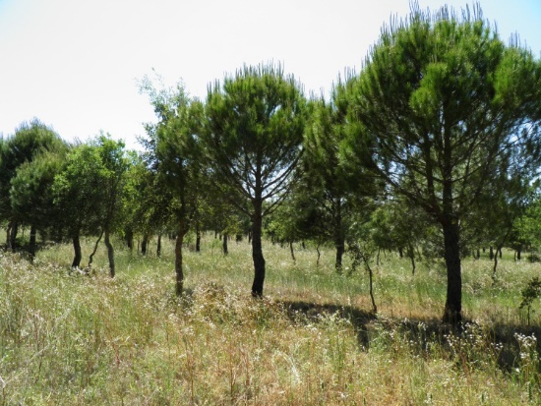 | 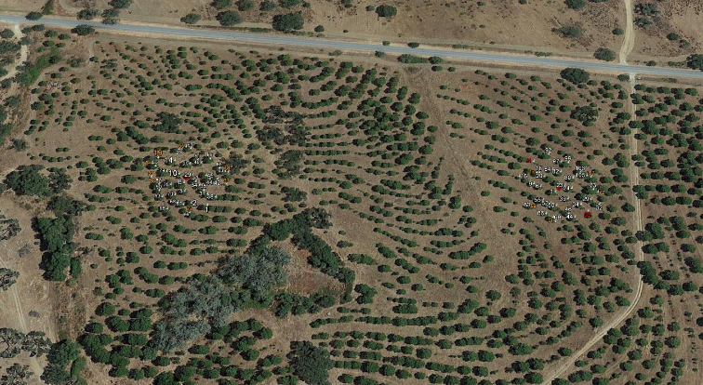
- Generate two alternative Forest Management Approaches, one considering a management toward fruit production and the other aiming for wood production (Table 1).

 | Final harvest age | Thinning residual basal area | Age of 1st thinning | Age of last thinning | Thinning periodicity (years) | Weed control periodicity
Fruit | 120 years | 15 m² ha⁻¹ | 10 | 90 | 10 | Every 5 years
Wood | 120 years | 25 m² ha⁻¹ | 10 | 90 | 10 | Every 5 years

- Simulate the growth of each plot with the PINEA model using StandsSIM simulator considering both FMAs and plot the evolution of the following sustainability indicators: Carbon stock, Carbon sequestered, harvested volume, fruit production. For the simulation:
- Plot 1 has 35 trees, plot 2 has 34 trees
- use the climatic data from the closest meteorological station (Évora)
- consider an altitude of 275 m
- use the economics and the consumables default files
- update the assortments file: wood price (m3) =32€ and pine cone price (kg) = 1.2€

- Analyze the Net Present Value in the output and indicate which FMA would you recommend and justify why

PINEA-tree. Comparing two alternative management approaches
Simulate for a planning horizon of 100 years the following existing stone pine stand:
- Location: Évora municipality
- Stand structure: even-aged
- Age: 18 years
- Number of trees in the plot: 34 trees
- Plot area: 2000 m2
- Altitude: 275 m (if you don’t know the altitude you can use the webGLOBULUS stand simulator to obtain it)
- Tree data file: “inv_Pm_arv_n34.csv”

- Generate two alternative Forest Management Approaches, one considering a management toward fruit production and the other aiming for wood production (Table 1). (suggestion: adapt the existing FMA41_Pm_15_REGular.csv and FMA41_Pm_25_REGular.csv).

 | Final harvest age | Thinning residual basal area | Age of 1st thinning | Age of last thinning | Thinning periodicity (years) | Weed control periodicity
Fruit | 100 years | 15 m² ha⁻¹ | 20 | 85 | 10 | Every 5 years
Wood | 100 years | 25 m² ha⁻¹ | 20 | 85 | 10 | Every 5 years

- Simulate the growth of each plot with the PINEA model using StandsSIM simulator considering both FMAs and plot (both alternatives in the same graph) the evolution of the following sustainability indicators: Carbon stock, Carbon sequestered, harvested volume, fruit production. For the simulation:
- Analyze the Net Present Value in the output and indicate which FMA would you recommend and justify why

PINEA-tree. Comparing two alternative management approaches
Suppose that you were given the task of simulating the growth of the following existing stand:
- Location: Alcácer do Sal municipality
- Stand structure: even-aged
- Age: 10 years
- Number of trees in the plot: 136 trees
- Plot area: 5000 m²
- Altitude: 100 m (if you don’t know the altitude you can use the webGLOBULUS stand simulator to obtain it)
- Tree data file: “inv_Pm_arv_n136.csv”

- Generate two alternative Forest Management Approaches, one considering a management toward fruit production and the other aiming for wood production (Table 1). (suggestion: adapt the existing FMA41_Pm_15_REGular.csv and FMA41_Pm_25_REGular.csv).

 | Final harvest age | Thinning residual basal area | Age of 1st thinning | Age of last thinning | Thinning periodicity (years) | Weed control periodicity
Fruit | 115 years | 13.5 m² ha⁻¹ | 15 | 100 | 10 | Every 5 years
Wood | 115 years | 30 m² ha⁻¹ | 15 | 100 | 10 | Every 5 years

- Simulate the growth of each plot with the PINEA model using StandsSIM simulator considering both FMAs and plot (both alternatives in the same graph) the evolution of the following sustainability indicators: Carbon stock, Carbon sequestered, harvested volume, fruit production. For the simulation:
- Analyze the Net Present Value in the output and indicate which FMA would you recommend and justify why

SUBER. Comparing different periodicities of debarking in an existing cork oak stand
Consider a planning horizon of 100 years and use the SUBER to simulate the growth of the following existing stands:
Location | Age(years) | Plot area (m²) | Tree data file:
Coruche | 10 | 2000 | inv_Sb_HBolota_arv.csv
Chamusca | 11 | 33928 | inv_Sb_HChaparro_arv.csv
Coruche | 15 | 2000 | inv_Sb_HBacaros_arv.csv
Grandola | 13 | 2000 | inv_Sb_HPernassada_arv.csv

FMA: use the EXCEL file FMA_Sb_RVariable_CCVariable_lag.csv to build FMAs with the following operations:

Year of 1st occurence | Periodic (Y-yes; N-no) | Periodicity | Operation
5 | Y | 4 | Manual weed control and Application of fertilizer
8 | N |  | Formation pruning (30% of the trees)
10 |  |  | Thinning (% crown cover = 35)
12 | N |  | Formation pruning (10% of the trees)
15 | N |  | Thinning (% crown cover = 35)
t_{d} [19;40] | Y | ? | Cork extraction
t_{d} | N |  | Formation pruning (10% of the trees)
t_{d} | Y | 9 | Thinning (% crown cover=35)
Start by running SUBER selecting the debarking operation at 40 years of age to find the age at which the dug is close to 17 cm and use it as the age to start cork debarking.
Run the SUBER for several alternative FMAs that differ among them by the periodicity of debarking and compare the results.

SUBER. Comparing different years to start the debarking in an existing cork oak stand
Consider a planning horizon of 100 years and use the SUBER to simulate the growth of the following existing stands:
Location | Age(years) | Plot area (m²) | Tree data file:
Coruche | 10 | 2000 | inv_Sb_HBolota_arv.csv
Chamusca | 11 | 33928 | inv_Sb_HChaparro_arv.csv
Coruche | 15 | 2000 | inv_Sb_HBacaros_arv.csv
Grandola | 13 | 2000 | inv_Sb_HPernassada_arv.csv

FMA: use the EXCEL file FMA_Sb_RVariable_CCVariable_lag.csv to build FMAs with the following operations:

Year of 1st occurence | Periodic (Y-yes; N-no) | Periodicity | Operation
5 | Y | 4 | Manual weed control and Application of fertilizer
8 | N |  | Formation pruning (30% of the trees)
10 |  |  | Thinning (% crown cover = 35)
12 | N |  | Formation pruning (10% of the trees)
15 | N |  | Thinning (% crown cover = 35)
t_{d} [19;40] | Y | 9 | Cork extraction
t_{d} | N |  | Formation pruning (10% of the trees)
t_{d} | Y | 9 | Thinning (% crown cover=35)

Run the SUBER for several alternative FMAs that differ among them by the age of the first cork debarking and compare the results to find the best age to start the cork extraction.
Go to the output with the diameter distributions (file SUBER_Output_DDPOV.csv) and plot the diameter distribution at the age selected the first debarking.

