Modelling Forest Ecosystems
- PBRAVO diameter distribution model

- Weibull: Implement the 3-parameters Weibull distribution in EXCEL in order to distribute a total of 100 trees ha⁻¹ according to the following parameter combinations:

 | a | b | c | Weibull
Situation 1 | 2 | 9 | 1.5
Situation 2 | 2 | 9 | 3.6
Situation 3 | 2 | 18 | 7
Situation 4 | 2 | 5 | 1

Consider diameter classes of 2 cm starting at zero and ending at 54 cm.
- PBRAVO: consider the data from the continuous forest inventory of the National Forest of Leiria – stand nº 2 as described below

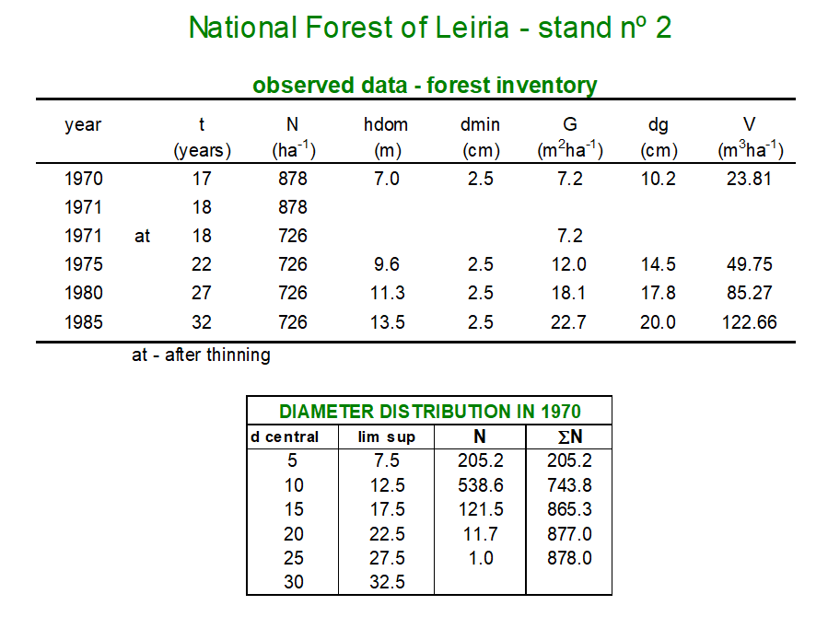
  - Use the equations that make up the model that are listed in the word file 14_PBRAVO_model.pdf and program the model in EXCEL for year 1970. Consider that parameter c of the Weibull distribution takes the value 3.1.

  - Using the observed data try to reproduce the observed values with the PBRAVO stand simulator. Use, in each year, the estimates of the c parameter given by the PBRAVO model.

