Modelling Forest Ecosystems
- Individual Tree models – Tree mortality/survival

- The data in file 15_ImplementingMortality_628Data.xlsx characterizes a 500 m² plot from the Portuguese NFI, containing the values of the crossed diameters of each tree (dm) and a code to identify dominant trees. Determine the set of trees that will die using the following survival equation:

Where d is the tree diameter at breast height (cm), G is stand basal area (m² ha⁻¹) and G_{>d} is the basal area of all trees with a diameter greater than the subject tree (m² ha⁻¹).

1.a. calculate the average diameter (d)
1.b. calculate the sectional area of each tree (gi)
1.c. calculate the basal area of the stand (G)
1.d. sort the data by diameter (descending)
1.e. calculate the sum of basal areas greater than the subject tree
1.f. apply the probability equations
1.g draw a random number to determine whether the tree survives

- Individual Tree models - Simulating thinnings for maritime pine using Wilson factor as criteria

- Use StandsSIM.md to simulate an existing stand for the following FMAs (50yrs FMA) using the tree list default file made available in the simulator. (You have to download the file - Pb_R_20yrs_500m2.xlsx to your computer before you can uploaded it to the simulator). The file contains the list of trees from a 500 m² plot in a 20 years old even-aged stand located in Leiria National Forest (altitude 10 m). Consider a planning horizon of 50 years and a final cut of 50yrs.
Thinning 1 | Thinning 2
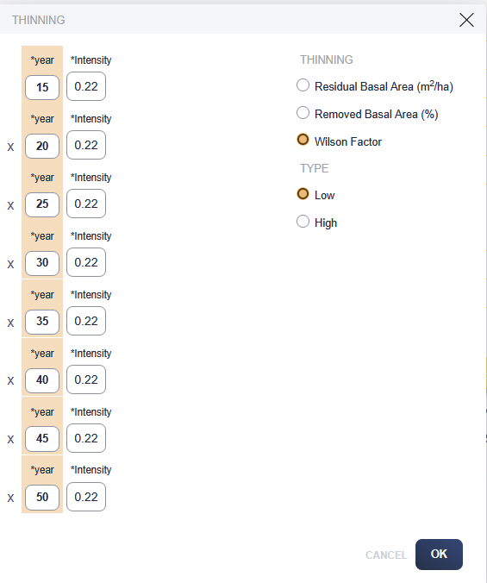 | 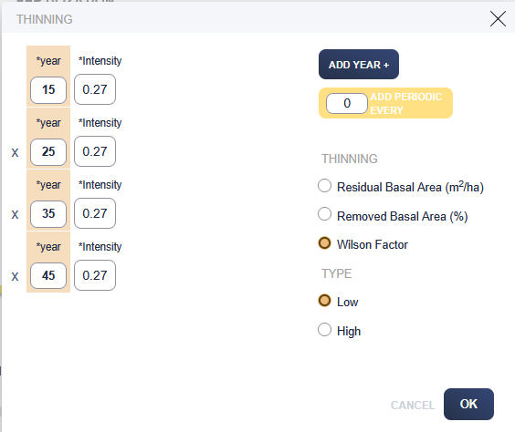
Assortments
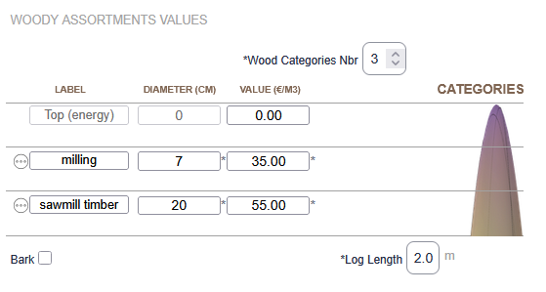

- Individual Tree models - Simulating thinnings for stone pine using residual basal area as criteria

  - Use StandsSIM.md to simulate a new plantation (S=20) for Pinus pinea following the FMAs (100 yrs FMA). Consider a planning horizon of 100 years and a final cut at 100yrs.

3.a. Consider a number of trees per hectare of 1000 and the first thinning to take place at age 20 with a periodicity of 15 years after. Two assortments should be considered and a top diameter of 5 cm with the wood being sold for 50 €/m³ and the cones for 0.4€/kg.

Nr trees at planting:
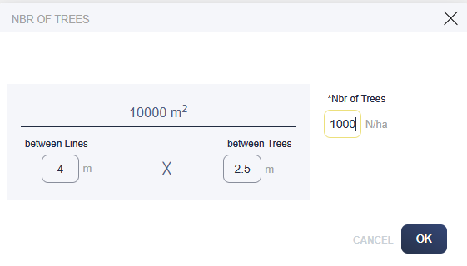
Thinning 1: | Thinning 2:
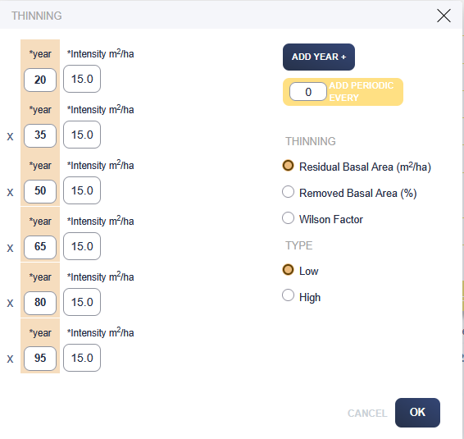 | 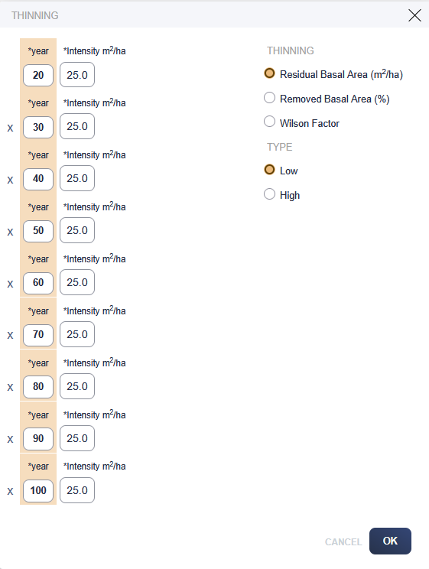

3.b. Consider a number of trees at planting of 250. Redefine your thinning schedule to guarantee a good production of cones. Suggestion: simulate a 1st time without any thinning and use the output table to guide you plan your thinning regime based on the residual basal area evolution.

- Individual Tree models - Simulating debarking for cork oak

  - Use StandsSIM.md to simulate an existing stand for cork oak using the tree list default file made available in the simulator. (You have to download the file - Sb_R_48yrs_1000m2.xlsx to your computer before you can uploaded it to the simulator). The stand had a forest inventory before debarking in 1999.

Consider a planning horizon of 80yrs and the following FMAs:

    - Planting 400 trees ha⁻¹ and debarking every 9 yrs starting at age 23
    - Planting 400 trees ha⁻¹, debarking every 9 yrs starting at age 23, increasing debarking height at ages 66 and 75

Comment the differences.

